Core Concepts and Key Insights
Virtual Machines (VMs) represent the core of Azure’s Infrastructure as a Service (IaaS). Each VM provides a defined number of virtual CPUs, memory, and resources, running an OS like Windows or Linux, fully managed inside by the user.
Virtual Machine Scale Sets (VMSS) enable horizontal scaling of VMs. They allow automatic addition/removal of VM instances based on workload metrics like CPU utilization or queue length, supporting workload elasticity.
- Azure VMs run on Hyper-V, Microsoft’s hypervisor, layered above physical hardware (compute, storage, networking). Users are responsible for OS management, patching, backup, security, and firewall configurations.
Azure offers different VM series and sizes tailored to workload types:
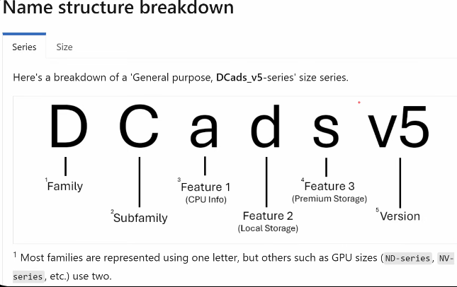
  - General purpose (balanced CPU and memory)
  - Compute optimized
  - Memory optimized
  - Storage optimized
  - GPU and FPGA based
  - High performance compute (HPC)
VM processors include Intel, AMD, and ARM, with ARM offering price-performance advantages. VM SKUs are grouped into series (e.g., D, E) and versions (V3, V4, V5, V6) reflecting hardware generations and capabilities.
- CPU-Memory ratios vary by series, e.g., D series (1:4), E series (1:8), allowing optimized resource allocation.
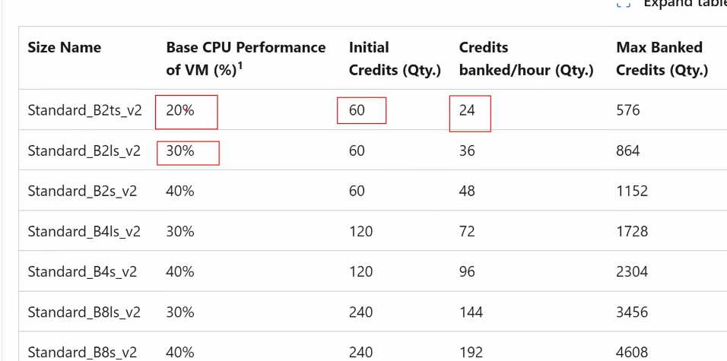
- Burstable VM SKUs (B series) if vm runs below baseline CPU performance then credits are accrued and if vm usage goes above baseline, credits are used. suitable for variable workloads. Ability to burst is not guaranteed as overprovisioning happens here, so if other users also burst at same time, you might not be able to avail the burst credits.
Microsoft does not over provision (except B series) like usually done on prem, so if a host has 8 vcpus, only 2 VMs with 4vcpus for example will be provisioned, taking care of the scenario where VM resource usage might reach 100%. If more VMs were provisioned for better utilizing resources in common idle scenarios, there might be issue like crashes during peak usage later.
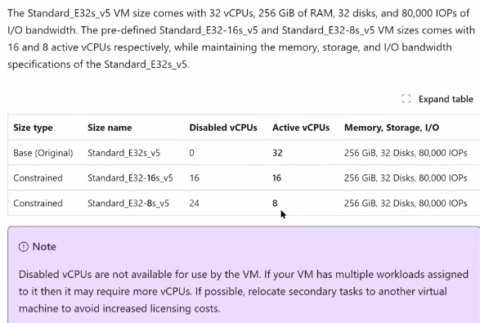
  - Constrained CPUs - allow you to reduce the number of active vCPUs while keeping the same amount of memory, storage, and I/O bandwidth. It’s useful when your workload needs lots of memory or I/O but doesn’t fully utilize all the CPU cores. Many enterprise software products (e.g., SQL Server, Oracle) are licensed per vCPU. By constraining CPUs, you reduce licensing costs while still getting the same memory and I/O capacity. Ideal for workloads that are memory-bound or I/O-bound rather than CPU-bound. Examples: large databases, in-memory analytics, caching layers.
- Confidential compute SKUs (DC series) offer hardware-based VM encryption:
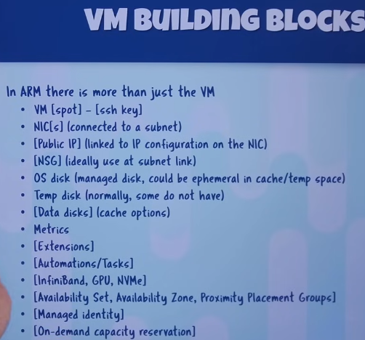
  - Intel SGX enclaves require app modifications.
  - AMD EPYC SKUs encrypt the entire VM without app changes.
VM generations:
  - Gen 1 uses BIOS/MBR boot. IDE for boot disk, SCSI for data disk.
  - Gen 2 uses UEFI/GPT, supporting virtual TPM and secure boot. SCSI for all disks so >2TB boot disk possible. Gen 2 is recommended for new deployments.
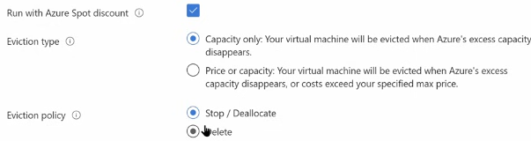
- Azure Spot VMs allow use of azure’s surplus capacity at a discount, with the risk of eviction based on demand, suitable for interruptible, batch, or non-critical workloads.
- Temporary disk - Every Azure VM (except some specialized SKUs) comes with a temporary disk, usually mounted as the D:\ drive on Windows or /dev/sdb on Linux. It is local storage physically attached to the host server running your VM. Purpose: Provides fast, ephemeral storage for operations that need high I/O but don’t require persistence. Data is not guaranteed to persist across VM reboots, stop/deallocate, or host maintenance. Very high throughput and low latency because it’s local SSD. Included in the VM price — no extra charge. Used for Pagefile / swap space, Caching, intermediate files, or temp folders, Scenarios needing fast ephemeral storage (e.g., rendering, batch jobs).
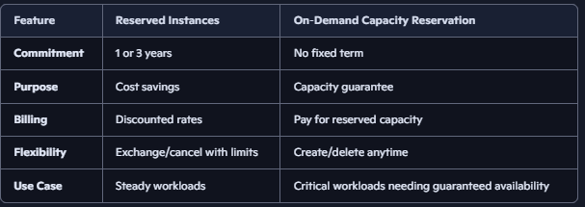
- Azure reserved instances - a billing discount model: you commit to a VM size/region for 1–3 years, and in return you get significant cost savings. You are reserving a price, not capacity as there is no guarantee that capacity is always available. They’re ideal for always-on workloads where you know you’ll need compute capacity long-term. You can exchange reservations for different VM families/regions. You can cancel reservations (with a fee) if your needs change. If you run more VMs than reserved, the extra ones are billed at pay-as-you-go. Reservations can be applied to: Virtual Machines, VM Scale Sets, Azure Dedicated Hosts, Some other compute services (SQL DB, Cosmos DB also have reserved capacity options).
- Azure On-Demand Capacity Reservation lets you reserve VM compute capacity in a specific region or availability zone without committing to a 1- or 3-year term. You can create, use, and delete reservations at any time, ensuring guaranteed VM availability when you need it most. Ensures that when you deploy VMs, the capacity is available even during regional demand spikes. SLA backed.
- Isolated VMs - VMs with very large sizes that consume almost whole of the host resources.
- Dedicated Hosts provide single-tenant physical servers for compliance or isolation, aligning with VM SKU series and allowing custom VM placement on the host. Pay for entire host box and can place many VMs on it from series that allign with the host series. Provides visibility into host maintenance events. Useful for BYOL (Bring Your Own License) scenarios — e.g., Windows Server, SQL Server — where licensing is tied to physical cores.
- Azure Local is Microsoft’s distributed infrastructure solution that extends Azure services directly into customer-owned environments, combining Azure Stack HCI (underlying OS) with Azure Arc (management portal along with azure portal) to run VMs, containers, and select cloud services locally while still being managed through the Azure control plane.
- SAP HANA on Azure Large Instances - Dedicated, bare-metal servers provisioned in Azure specifically for SAP HANA workloads.
- Nutanix Cloud Clusters (NC2) on Azure - Nutanix’s hyperconverged infrastructure stack running directly on bare-metal Azure instances. Deploy Nutanix AHV/Prism on Azure bare-metal nodes. Provides consistent Nutanix experience across on-prem and Azure. Integrated with Azure networking and services.
Maintenance and resiliency:
  - Azure does planned maintenance with live migration / memory-preserving updates (vm memory is frozen, hypervisor updates and reboots, vm memory unfrozen so no issue except some downtime).
  - Users must plan for patches, backups, OS reboots, and DR.
  - Use availability zones, fault domains, and availability sets for high availability.
Patching approaches:
  - Guest OS auto-patching risks simultaneous failures. Don’t patch everything together.
  - Third-party tools and Azure Update Management provide controlled, orchestrated patching with advanced management.
  - Azure Automatic Guest Patching offers basic rolling updates aligned with availability sets. Critical and security patches only. Off-peak, availability first principals.
- Instance Metadata Service (IMDS) is accessible inside the VM via a fixed IP 169.254.169.254, providing VM’s info from control plane (size, tags, region, network config) and user data (script, configuration file, or other data available to apps inside vm throughout its lifetime) for customization.
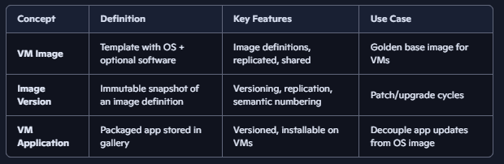
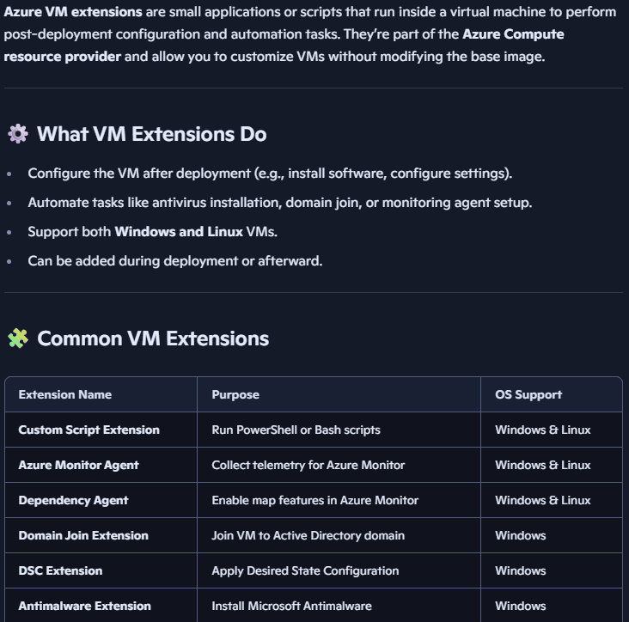
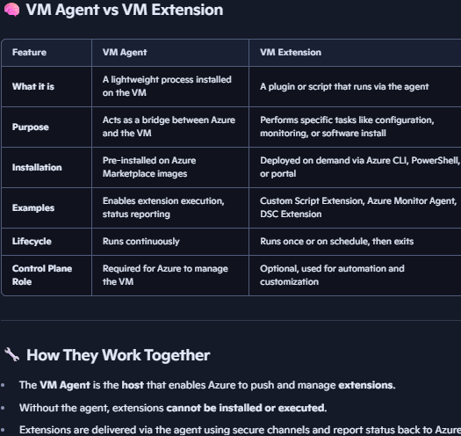
- Azure Compute Gallery (formerly Shared Image Gallery) A repository service which enables creation, versioning, regional replication of resources (vm images / vm apps), and sharing of custom VM images (template containing OS and optionally pre-installed software/configs) and associated applications for consistent deployment. Can be shared across tenant or subscription. For each replica of an image in any region, 50 concurrent vm deployment is recommended limit, so increase replica if more concurrent deployments needed. Each image definition can have multiple versions (e.g., v1.0, v1.1, v2.0). Allows you to update your golden image while keeping older versions available. Each version is immutable once published. VM Applications is a newer feature in Compute Gallery that lets you package and distribute applications separately from the VM image. Instead of baking every app into the image, you can maintain a clean base image and deploy apps dynamically from package stored in blob (using install/uninstall/update scripts). VM apps are stored in the gallery like images. Can be versioned (e.g., App v1.0, v1.1). Installed on VMs during provisioning or later via extensions. Decouples OS image lifecycle from application lifecycle. Easier to update apps without rebuilding the entire image.
- Azure VMware Solution offers a first-party VMware environment running ESXi on Azure hardware, enabling migration without retooling but with separate networking and storage constructs.
Virtual Machine Scale Sets (VMSS):
  - Support automatic horizontal scaling based on metrics. VMSS integrates with Azure Load Balancer or Application Gateway for traffic distribution.
  - Two orchestration modes: Uniform (legacy, homogeneous VMs, managed as a single resource group, works seamlessly with Azure Load Balancer, best for stateless workloads like web front ends, api services, batch processing) and Flexible (new, supports mixed VM sizes, images, spot instances, built on Azure Availability Sets and Availability Zones concepts, best for databases or stateful apps where you want different VM roles in one scale set).
  - Supports rolling updates, auto image updates, instance repair, instance protection.
  - Enables predictive scaling using historical data.
- Compute Fleet (preview) targets massive-scale batch workloads, supporting up to 10,000 VMs across AZs + regions with spot and pay-as-you-go mix.

Timeline Table of Key Azure VM Features (Conceptual)
Feature/Concept | Description | Notes
Basic VM | Single VM with fixed CPU, memory, OS | User manages OS and apps
VM Series & Sizes | Different VM SKUs for specialized workloads | D, E, N, H, etc. with Intel, AMD, ARM CPUs
Generation 1 vs 2 | BIOS/MBR vs UEFI/GPT boot | Gen 2 supports virtual TPM, secure boot
Burstable VMs (B series) | Baseline CPU + burst credits | Useful for spiky/variable workloads
Confidential Compute | Hardware-level encryption | Intel SGX (app changes needed), AMD full VM
Azure Spot VMs | Discounted, interruptible VMs | Eviction risk, suitable for batch jobs
Dedicated Hosts | Single-tenant physical server | Regulatory/compliance use cases
VM Maintenance | Live migration or memory-preserving host updates | Requires planning for patching/DR
Azure Update Management | Controlled patch orchestration | Supports hot patch, custom schedules
Instance Metadata Service | VM internal API for metadata & user data | Enables dynamic VM configuration
Azure Compute Gallery | Image/app versioning & replication | Supports sharing and multi-region deployment
Azure VMware Solution | VMware environment on Azure hardware | Enables lift-and-shift migrations
Virtual Machine Scale Sets | Auto horizontal scaling of VMs | Flexible (modern) and Uniform (legacy) modes
Compute Fleet (Preview) | Massive scale compute across regions | Up to 10,000 VMs, mix of spot & on-demand

Azure VM Series Comparison (Simplified)
VM Series | Focus Area | Memory to vCPU Ratio | CPU Types Supported | Example Use Cases
D Series | General purpose | 1:4 | Intel, AMD, ARM | Web servers, app servers
E Series | Memory optimized | 1:8 | Intel, AMD | Databases, in-memory caches
B Series | Burstable | Not fixed | Intel | Variable workloads, dev/test
N Series | GPU accelerated | Varies | Intel | AI, graphics rendering, HPC
H Series | High performance compute | Varies | Intel | HPC, scientific simulations
Confidential DC/DCA | Confidential compute | Varies | Intel SGX / AMD EPYC | Secure workloads requiring VM encryption

Key Features of Virtual Machine Scale Sets (VMSS)
- Automatic scaling based on configurable metrics (CPU utilization, queue depth, etc.).
- Two orchestration modes:
  - Uniform: all VMs identical, no spot/non-spot mix.
  - Flexible: mixed VM sizes, spot and non-spot instances, manual VM addition.
- Fault domain and availability zone awareness for high availability.
- Rolling updates of VM images and configurations with rollback support.
- Instance protection to prevent critical VMs from scaling in.
- Instance repair and auto-healing capabilities.
- Predictive scaling using historical metrics to scale proactively.

Additional Management and Operational Insights
- Azure does not overprovision CPU resources (guaranteed CPU availability per VM).
- For patching and maintenance, best practice is gradual rollout (ring deployment) to minimize risk.
- Azure’s instance metadata service allows VMs to dynamically query their environment and customize behavior via user data.
- Azure Auto Manage simplifies VM lifecycle management by automating backup, patching, security, and compliance configurations based on environment profiles.
- Temporary disks (local storage on host) exist for caching but are ephemeral and data loss prone; do not store critical data there.
- VM networking supports multiple NICs, accelerated networking, network security groups, and integration with Azure firewalls/load balancers.
- Dedicated hosts and isolated VMs provide physical isolation for compliance or security-sensitive workloads.
- Azure VMware Solution offers a VMware environment in Azure with familiar VMware tools, using ESXi hypervisor instead of Hyper-V.

